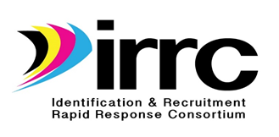
STATE IDENTIFICATION & RECRUITMENT PLAN CHECKLIST
State: Contact Person:

Purpose: To ensure and demonstrate alignment between laws, regulations, and guidance and the state ID&R plan
ID&R Plan Components | Included | In Progress | Not Included | Comments and Notes
- Mission Statement
II. Measurable Objectives
- Professional Development
- Identification and Recruitment
- Quality Control
- Interstate/Intrastate Coordination
III. Activities/Strategies
- Professional Development
- Identification and Recruitment
- Quality Control
- Interstate/Intrastate Coordination
IV. State Resources
- Professional Development
- Identification and Recruitment
- Quality Control
- Interstate/Intrastate Coordination
V. Action Plan
- Staff assignments
- Timeline

Please provide a brief narrative outlining your state’s ID&R plan development process and progress-

NEXT STEPS:

1. Have areas still in progress been identified?

2. Are there areas in which IRRC technical support is needed?

